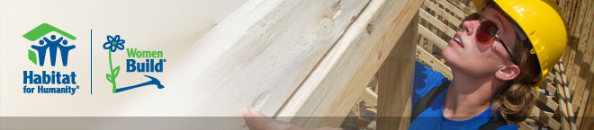
HABITAT FOR HUMANITY NATIONAL WOMEN BUILD WEEK, 2018
Dates: Wed. May 9, Fri. May 11,
from 8-11:30am or 12-3pm.
*Help a family towards a better future~learn how to build~have fun~make new friends~enjoy the outdoors*
Substandard housing is a severe threat to children’s health, growth and potential. So many in our community cannot afford the high rentals and mortgages. Habitat provides the chance to own a safe and decent home. You have the potential to change people’s lives forever!
Our goal is simple, but great: empower women to take action against substandard housing conditions to make a family’s dream of home ownership a reality. You can help by joining us as we take up hammers, saws, and nails.
Join the Women Build Team as we celebrate National Women Build Week by helping build the home of a family with 6 children and raise funds towards building materials. No experience necessary.
Register with us soon, as this is a popular event.
Contact for more information and forms:
Coralie.gilson@yahoo.com. 386-428-5010.
